|  |
| --- |
| **Front End Engineering-II**      Project Report  Semester-III (Batch-2023)    Real Estate Webpage        **Supervised By: Submitted By: Group 10**  Dr. Amitabh Srivastava Aryan Walia (2310990305)  Professor Ashmit Goyal (2310990306)  Chitkara University, Punjab Drishti (2310990330)          **Department of Computer Science and Engineering**  **Chitkara University Institute of Engineering & Technology, Chitkara University, Punjab** |

###### TABLE OF CONTENTS

|  |  |  |
| --- | --- | --- |
| Sr.no | Section | Page no |
| 1. | Introduction | 2-9 |
| 2. | Problem Definition and Requirements- | 10-11 |
| 3. | Proposed Design / Methodology | 12-14 |
| 4. | Results | 15-21 |

1. **Introduction**
   1. **Background**

A real estate website is an online platform that provides information and services related to buying, selling, and renting properties. These websites have become an essential tool for individuals, real estate agents, and property developers to showcase properties, connect with potential buyers or renters, and facilitate transactions.

* + 1. **Target Audience**

The target audience for a real estate website is a diverse group of individuals and organizations. Homebuyers, including first-time buyers, repeat buyers, and those looking to upgrade or downsize, are a key segment. Renters, such as students, young professionals, and families, are another important group. Real estate agents and agencies, property developers, and investors, including those seeking rental income or long-term appreciation, also utilize the website. Additionally, researchers and browsers who are interested in staying informed about the real estate market, trends, and prices are part of the target audience. Furthermore, demographics, location, and property type can influence the type of properties and services users are interested in. Understanding the target audience is crucial for creating a user-friendly and effective real estate website.

* + 1. **Technology Stack**

A typical technology stack for a real estate website may include a combination of systems and tools for tasks such as digital marketing, lead capture, and database management. This can include web development (both frontend and backend), mobile app development, and database management for storing property listings and user data. The tech stack may also include tools for customer relationship management (CRM), marketing automation, and analytics. Additionally, it may include tools for virtual tours, property valuation, and transaction management.

* 1. **Objectives**
     1. **Showcase Properties Effectively:**

The core function of any real estate website is to present available properties in the most appealing and informative way possible. This includes:

* **High-Quality Visuals**: Large, high-resolution images that capture every detail of a property, from interior rooms to exterior views and nearby amenities.
* **Detailed Listings**: Each property should have a comprehensive description that includes the number of bedrooms and bathrooms, square footage, location, and any unique selling points (e.g., a swimming pool, proximity to schools, etc.).
* **Multimedia Features**: Offering virtual or 3D tours, videos, and interactive floor plans to give potential buyers or renters an immersive experience.
* **Interactive Maps**: Integrate Google Maps or a similar tool to allow users to explore the neighborhood, nearby services (schools, hospitals, shopping centers), and property locations visually.
* **Clear Pricing**: Transparent and up-to-date pricing should be available for all properties, including mortgage calculators to give users a sense of affordability.
  + 1. **Enhance User Experience (UX):**

A great user experience is crucial to keeping visitors on the website and ensuring they can find what they’re looking for. This can be achieved by:

* **Intuitive Navigation**: Simple, clear menus and search functionalities that allow users to find listings, contact agents, or explore market insights easily.
* **Property Search and Filters**: Advanced search options that let users filter properties by price, location, number of rooms, property type (residential, commercial), and other criteria like pet-friendly or furnished options.
* **Mobile Responsiveness**: The website should be optimized for mobile devices, ensuring users can browse properties smoothly on smartphones and tablets.
* **Fast Loading Times**: Speed is crucial, especially when showcasing high-resolution images and multimedia. Slow-loading pages could deter potential users.
  + 1. **Generate Qualified Leads:**

Lead generation is essential for turning website visitors into potential clients. A real estate website should:

* **Offer Call-to-Actions (CTAs)**: CTAs like "Schedule a Viewing," "Contact an Agent," or "Request More Information" should be visible on property listings to encourage users to engage.
* **Lead Capture Forms**: Implement forms for capturing essential information, such as name, phone number, email, and property preferences. This helps agents follow up effectively.
* **Email Subscriptions**: Offer users the ability to subscribe to newsletters or receive notifications about new properties that match their search criteria.
* **Incentives**: To encourage form submissions, offer tools like downloadable property guides, first-time buyer tips, or calculators (e.g., mortgage, rental yield) that add value for users.
  + 1. **Build Trust and Credibility:**

Trust is vital in the real estate industry, and the website should foster credibility through:

* **Client Testimonials and Reviews**: Showcase real-life success stories and testimonials from satisfied clients, whether they’ve bought, sold, or rented properties through the platform.
* **Agent Profiles**: Highlight the experience and expertise of the real estate agents with detailed profiles, including their qualifications, local knowledge, and client reviews.
* **Certifications and Associations**: Display any real estate licenses, awards, or affiliations with well-known industry bodies (e.g., National Association of Realtors) to establish trust.
* **Market Expertise**: Offering market reports, trend analyses, and expert advice on the website can position the company as a reliable source of real estate information.
  + 1. **Facilitate Communication Between Buyers, Sellers, and Agents:**

The website should act as a bridge between potential buyers, sellers, and agents by:

* **Multiple Communication Channels**: Provide users with various ways to get in touch, such as live chat, direct messaging, email, or phone contact details for agents.
* **Appointment Scheduling**: Integrate scheduling tools that allow users to book property viewings or consultations with agents directly through the website.
* **Instant Inquiry Response**: Automate follow-up emails or messages for property inquiries to ensure leads are nurtured immediately.
* **FAQs and Help Sections**: Include a section for frequently asked questions or guides to help users with common queries about buying, selling, renting, or financing.
  1. **Significance of the Project**

A real estate website is essential for transforming the property market by providing round-the-clock access to property listings, making it easier for buyers, renters, and sellers to explore options at their convenience. It eliminates the need for in-person visits by offering detailed property information, high-quality images, and virtual tours, allowing users to make informed decisions from anywhere. This digital platform expands the reach of properties beyond local markets, helping sellers attract a larger audience and potential buyers from different regions or even internationally.

In addition to accessibility, a real estate website is a cost-effective marketing tool, enabling businesses to showcase listings and update them instantly without the expense of traditional advertising. By integrating advanced search filters and comparison features, it enhances user experience and streamlines the property search process. Websites also build trust and credibility through client testimonials, agent profiles, and market insights, positioning the business as an expert in the field.

A well-designed real estate website is a powerful lead generation tool, capturing user data through contact forms and inquiries, allowing agents to follow up with potential clients effectively. With real-time updates on new listings and price changes, users can stay informed, improving engagement and decision-making. Integrated communication features such as live chat and scheduling tools further enhance customer interaction, making the buying or renting process more efficient.

Finally, having a strong online presence gives real estate businesses a competitive edge in today’s market. A professional website optimized for search engines increases visibility and helps businesses attract leads. Additionally, data analytics from the website provide insights into user behavior, allowing businesses to refine their strategies and improve performance. In a highly competitive industry, a real estate website is indispensable for driving growth and establishing a strong brand identity.

1. **Problem Definition and Requirements**
   1. **Problem Statement:**

In today’s fast-paced real estate market, buyers, renters, and sellers face challenges in efficiently accessing and navigating property listings. Traditional methods of property hunting are time-consuming and often provide limited information, resulting in a disjointed and frustrating experience for both users and real estate professionals. Buyers and renters struggle to find properties that match their specific needs due to a lack of advanced search filters, real-time availability updates, and detailed property insights such as virtual tours and neighborhood information. Sellers and agents, on the other hand, face difficulties in reaching a broad audience, generating qualified leads, and maintaining effective communication with potential buyers.

Moreover, many real estate businesses lack a professional online presence, which hampers their ability to showcase properties effectively, build credibility, and stay competitive. There is a need for an integrated platform that not only simplifies property search but also enhances user experience, boosts lead generation, and provides valuable market insights, while fostering trust between buyers, sellers, and agents.

* 1. **TECHNOLOGIES USED**
     1. **HTML**

HTML (HyperText Markup Language) is the foundational markup language used to create the structure of the e-commerce webpage. It provides the basic framework, including headings, paragraphs, images, links, and other elements that make up the content of the site.

* + 1. **CSS**

CSS (Cascading Style Sheets) is used to style the HTML content, enhancing the visual appearance of the webpage. It allows for the customization of colours, fonts, layouts, and other design aspects, ensuring a consistent and appealing look and feel across the site.

1. **Proposed Design / Methodology**

The proposed design and methodology for a real estate website aim to create a user-centric, efficient, and comprehensive platform that addresses the challenges faced by buyers, sellers, and real estate professionals. The website will feature a clean and intuitive interface with advanced search and filtering options to enhance the user experience. It will be responsive and optimized for all devices, ensuring seamless access across smartphones, tablets, and desktops. Property listings will be interactive, showcasing high-quality images, detailed descriptions, virtual tours, and interactive maps to provide users with a thorough view of each property.

On the backend, a robust database system will manage property listings and user data, integrated with Multiple Listing Services (MLS) for real-time updates. A user-friendly Content Management System (CMS) will facilitate easy content updates and management. Lead generation will be supported through easy-to-use forms, live chat, and CRM integration for effective follow-up and client relationship management. The site will also include valuable content such as market reports, neighborhood insights, and financial tools to assist users in making informed decisions.

SEO best practices and digital marketing strategies will be employed to enhance visibility and attract traffic, with features for social media integration to amplify reach. Data analytics will be used to monitor user behavior, website performance, and security, ensuring the site remains reliable and compliant with privacy regulations. By integrating these elements, the real estate website will provide a streamlined, engaging, and secure platform for all users involved in property transactions.

.

**3.1 Problem Statement:**

The current real estate website is outdated, difficult to navigate, and does not provide an optimal user experience. The website lacks essential features, such as property filtering, map views, and mobile responsiveness, resulting in low engagement and conversion rates. The goal of this project is to design and develop a modern, user-friendly, and feature-rich real estate website that meets the needs of both property buyers and sellers.

**3.2 Design Objectives:**

The design objectives for this project are:

* To create a visually appealing and modern website design that reflects the brand's identity
* To improve the user experience through intuitive navigation, clear typography, and high-quality visuals
* To increase engagement and conversion rates by providing essential features such as property filtering, map views, and mobile responsiveness
* To ensure the website is accessible and usable for all users, including those with disabilities
* To launch the website within 12 weeks

**3.3 Design Process**

**The design process for this project will consist of the following steps:**

1. Research and Analysis (Week 1-2)
   * Conduct user research to understand the needs and behaviors of property buyers and sellers
   * Analyze competitors' websites to identify best practices and areas for differentiation
   * Define the target audience and create user personas
2. Wireframing and Prototyping (Week 3-4)
   * Create low-fidelity wireframes to visualize the website's layout and structure
   * Develop high-fidelity prototypes to test the website's usability and functionality
3. Visual Design (Week 5-6)
   * Develop a visually appealing design concept that reflects the brand's identity
   * Create a style guide to ensure consistency throughout the website
4. Front-end Development (Week 7-8)
   * Write clean, semantic, and responsive HTML, CSS, and JavaScript code
   * Implement the design concept and ensure cross-browser compatibility
5. Back-end Development (Week 9-10)
   * Design and implement a robust and scalable database to store property listings
   * Develop a content management system (CMS) to manage property listings and user accounts
6. Testing and Quality Assurance (Week 11-12)
   * Conduct usability testing and gather feedback from users
   * Perform cross-browser and device testing to ensure compatibility
   * Conduct security testing to ensure the website is secure and protected against common web attacks
7. **Results**
   1. **Registration Page**



* 1. **Log-In Page**



* 1. 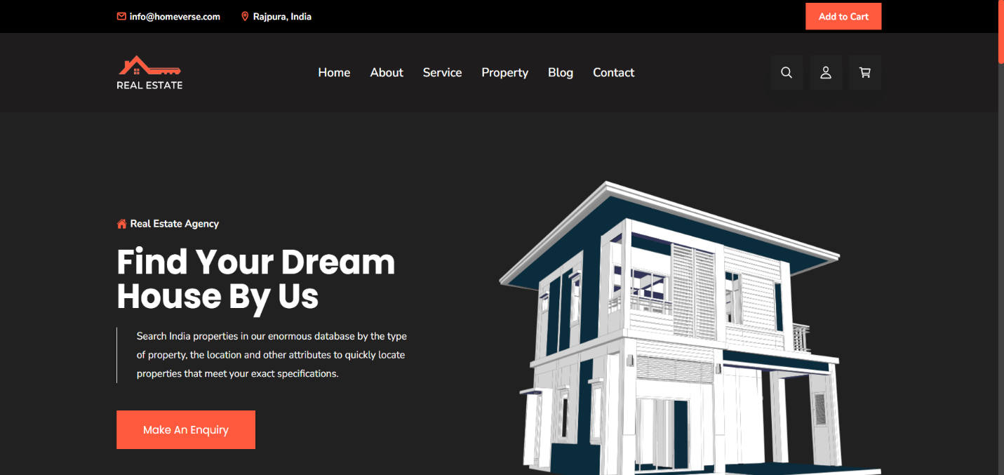**Main Page**

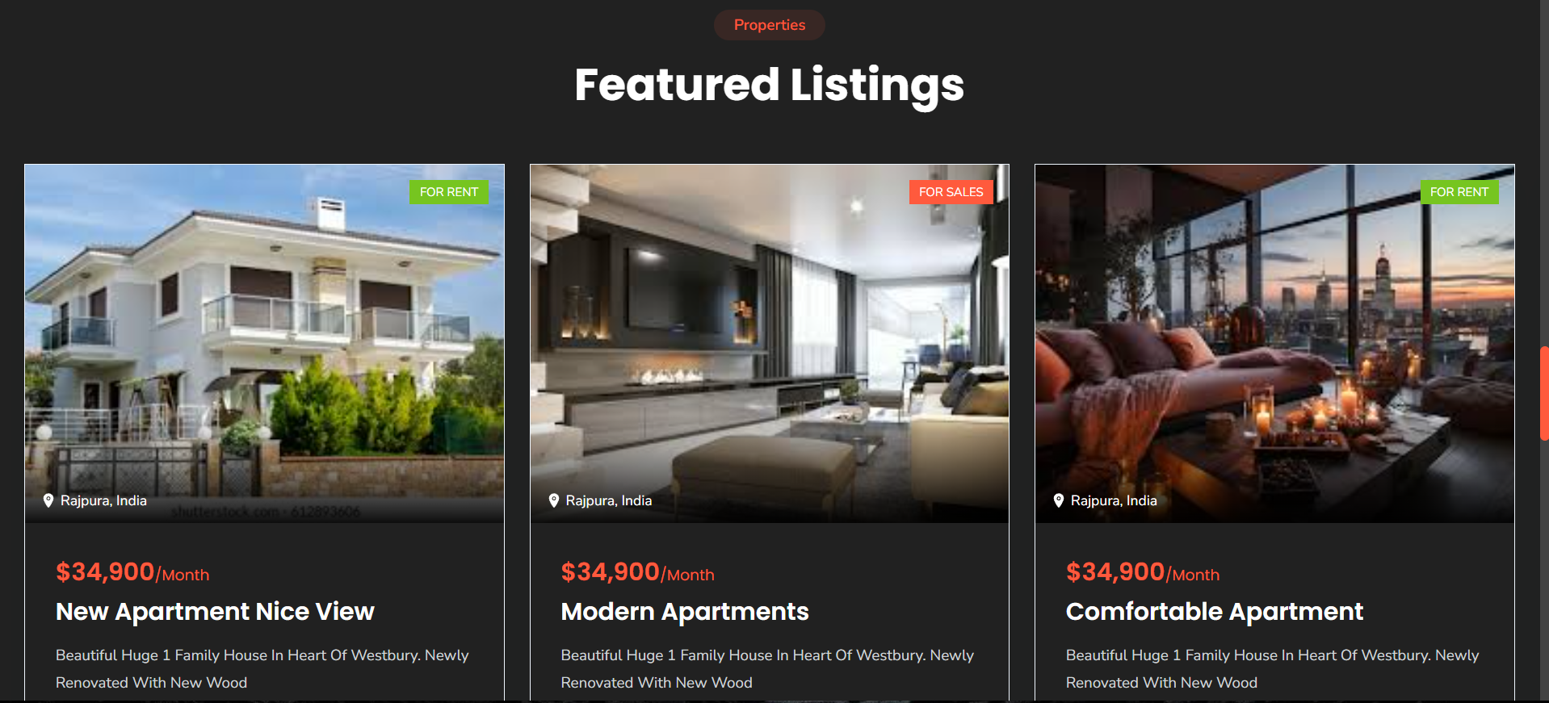

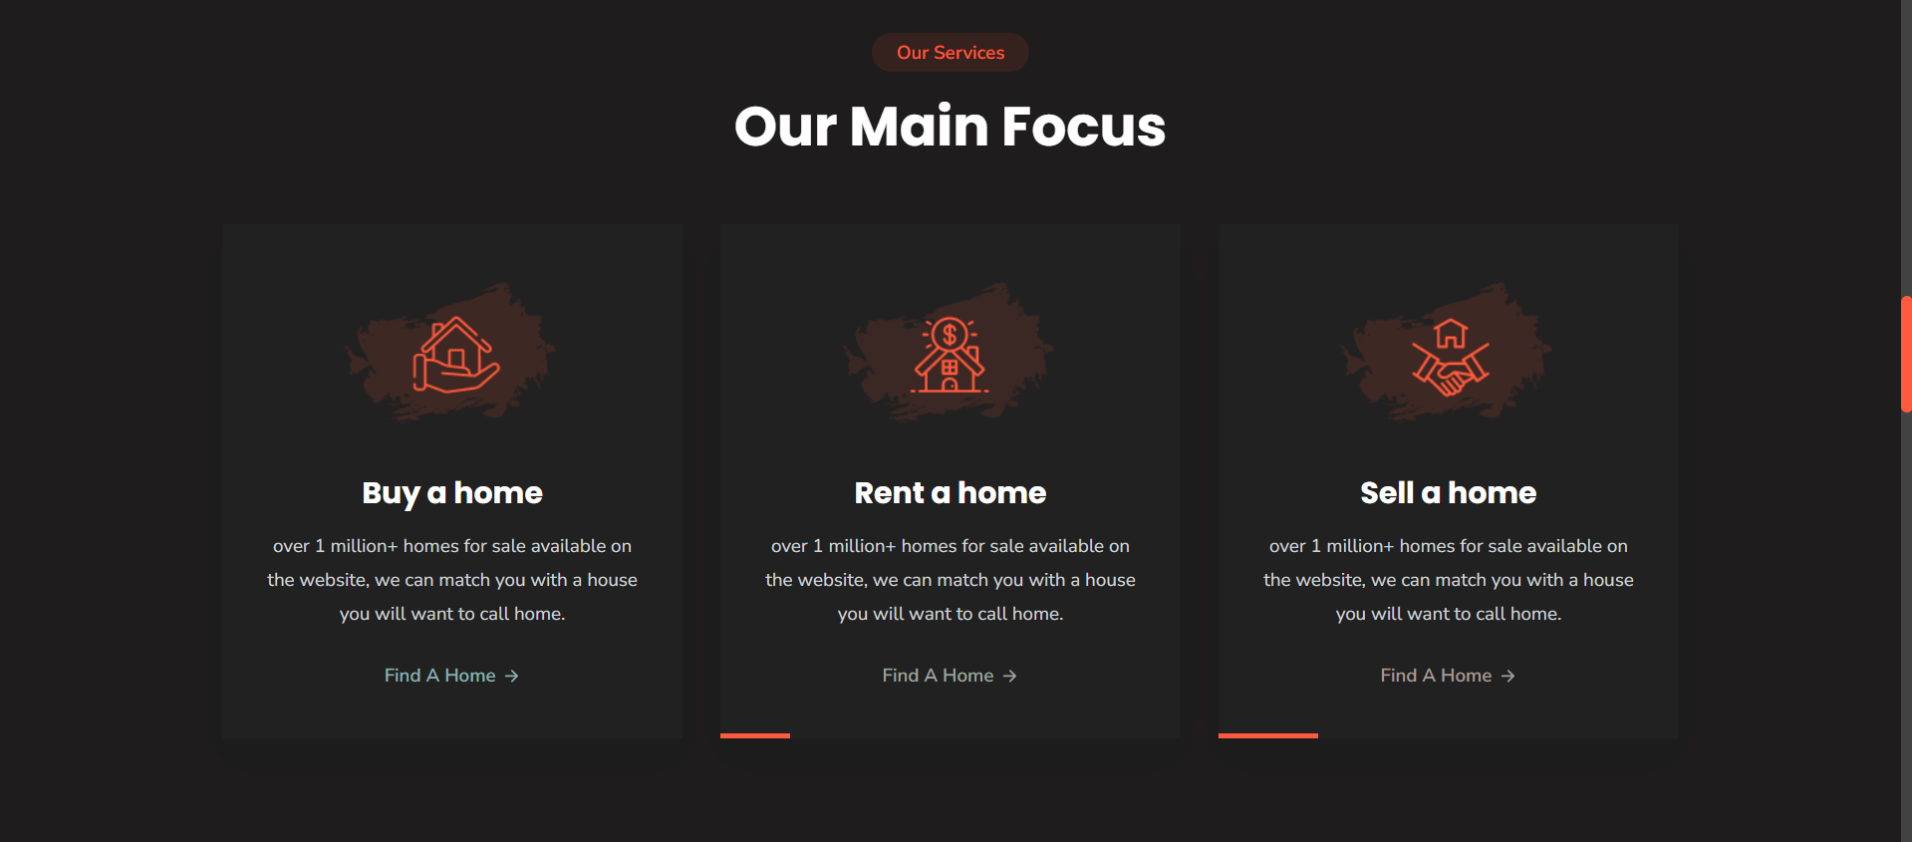

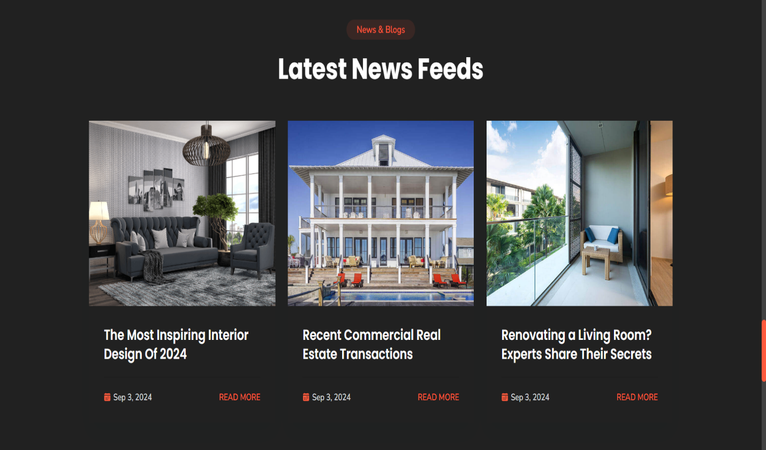

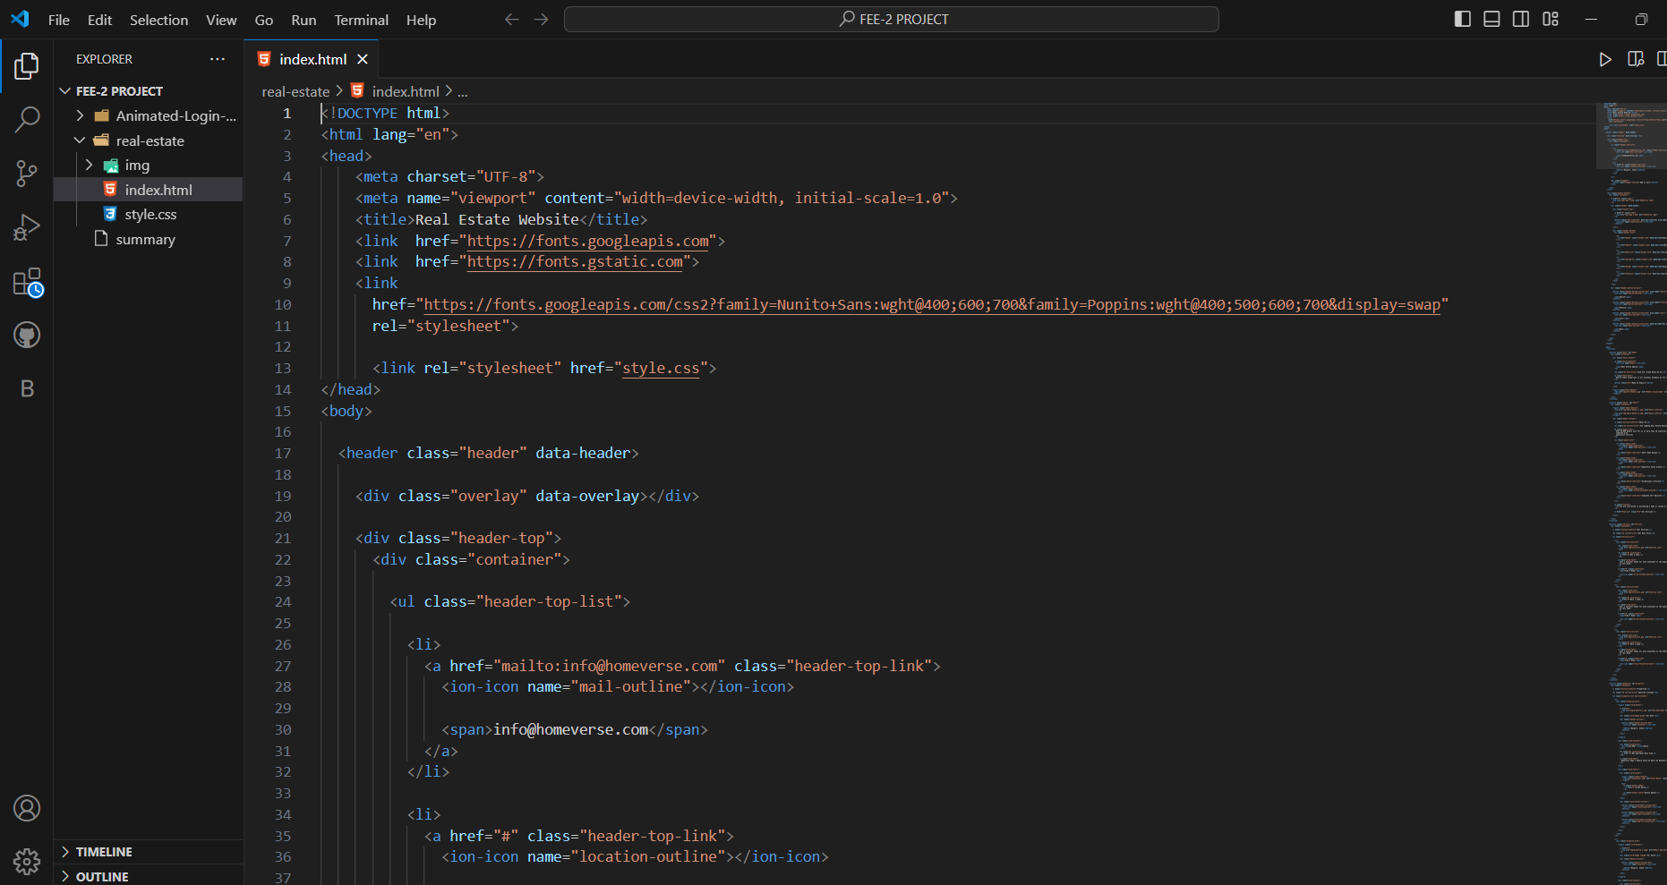**4.4. Code**



